WELCOME TO EMMANUEL

Emmanuel Episcopal Church was established in 1858. The first wooden structure was destroyed by a storm. The present building was erected in 1872 on a meager budget by faithful souls. They dug native fieldstone from nearby farms and used sand from Lee County creeks to make the mortar. For many years the interior was largely bare and furnishings were slowly added. The Church is the oldest public building in the city of Opelika and among the oldest buildings in Lee County. Emmanuel has been a mission church for most of the 150 years of its existence. In 1996, the architectural firm of Holmes & Holmes of Mobile, Alabama was employed to plan and supervise the renovation of the original building. The firm was asked to maintain the building’s architectural integrity, so while structural problems were corrected, the original appearance of the chancel was largely restored.

Emmanuel Episcopal Church is located at 800 First Avenue, Opelika, Alabama 36801. For more information call the Parish Office at (334) 745-2054 or send an e-mail to emmanuelopelika@bellsouth.net Visit us online at www.opiscopal.org. If you are a guest, please sign our church guest book by the front door.

TODAY’S ORDAINED/LAY MINISTERS

Celebrant The Rev. Liston Garfield
Lay Eucharist Minister Nancy Jonson
Organist & Music Director Preston Winkles

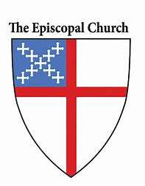

EMMANUEL EPISCOPAL CHURCH
800 First Ave.
Opelika, Alabama 36801

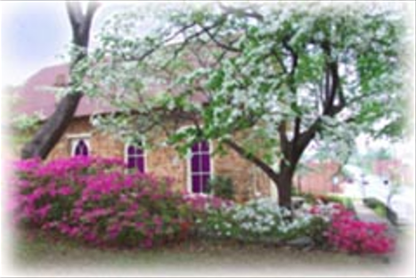

The Fourteenth Sunday after Pentecost
Holy Eucharist – Rite II

September 25, 2022

Order of Worship

Prelude
Entrance Hymn Immortal, invisible Hymnal 423
Word of God BCP Page 355
Gloria S-280
Collect of the Day Insert

The Liturgy of the Word

First Reading – Jeremiah 32:1-3, 6-15 Insert
Psalm 91:1-6, 14-16 Insert
Second Reading – 1 Timothy 1:12-17 Insert
Sequence Hymn Tell out my soul Hymnal 437
Gospel – Luke 16:19-31 Insert
Sermon The Rev. Liston Garfield
Nicene Creed BCP Page 358
Prayers of the People, Form III BCP Page 387
Confession of Sin BCP Page 360
The Peace BCP Page 360
Announcements

The Holy Communion

Offertory Hymn Fight the good fight Hymnal 552
Presentation Hymn Hymnal 380 (verse 3)
Eucharistic Prayer A BCP Page 361
Sanctus S-130
The Lord’s Prayer BCP Page 364
The Breaking of the Bread BCP Page 364
Agnus Dei S-164
Communion Hymn I am the bread of life Hymnal 335
Post Communion Prayer BCP Page 365
Recessional Hymn Lead on O King eternal Hymnal 555
Dismissal BCP Page 102
Postlude

Prayers of the People

Filip A., Carol A., Jordan A., Marie A., Petr A., Blaine & Terannie B.,
Bob & Cecelia B., Gavin B., Sara & Jason B., Tim B., John C.,
Patrick C., Barbara C., Francie G., Jacquelyn G., Jitka H.,
Rosalie H., Fred H.,Judy J., Bob J., Fr. Jack K., Meredith K.,
Greg & Ilene L., Jan L., Jay L., Jeanette L., Tom L., Rev. Bill M., Brandy M., John M., Linda M., Robbie M., Jack & Renee R.,
Mike & Jacqueline R., Ron R., Ann R., Bob S., Janeth & Fred S.,
Joanne & Bill S., Judy W., Beth & Frank Y.,

In Thanksgiving For: The Children of Emmanuel Church,
Emmanuel’s anonymous donors

For Those Who Have Died:

Announcements
Sept. 29 Compline - 7 pm
October 6 Compline - 7 pm
October 13 Compline - 7 pm
October 20 Compline – 7 pm
October 27 Compline – 7 pm
October 2 Sunday School begins at 11 am
October 16 Sunday School begins at 11 am

Emmanuel’s Service Schedule – Sunday – 10:00 am
October 2 Holy Eucharist, Rite II – The Rev. Liston Garfield
October 9 Morning Prayer, Rite II
October 16 Holy Eucharist, Rite II – The Rev. Liston Garfield
October 23 Holy Eucharist, Rite II – The Rev. Liston Garfield
October 30 Morning Prayer, Rite II

The people of Emmanuel Church offer a warm welcome to our guests. Please take a moment to sign our guest book near the front door. All baptized Christians of every denomination are encouraged to receive Holy Eucharist. If you are unable to come to the altar rail, please let the usher know you would like to receive the consecrated bread and wine in your pew.

Ladies Luncheons will resume in January, 2023

