WELCOME TO EMMANUEL

Emmanuel Episcopal Church was established in 1858. The first wooden structure was destroyed by a storm. The present building was erected in 1872 on a meager budget by faithful souls. They dug native fieldstone from nearby farms and used sand from Lee County creeks to make the mortar. For many years the interior was largely bare and furnishings were slowly added. The Church is the oldest public building in the city of Opelika and among the oldest buildings in Lee County. Emmanuel has been a mission church for most of the 150 years of its existence. In 1996, the architectural firm of Holmes & Holmes of Mobile, Alabama was employed to plan and supervise the renovation of the original building. The firm was asked to maintain the building’s architectural integrity, so while structural problems were corrected, the original appearance of the chancel was largely restored.

Emmanuel Episcopal Church is located at 800 First Avenue, Opelika, Alabama 36801. For more information call the Parish Office at (334) 745-2054 or send an e-mail to emmanuelopelika@bellsouth.net Visit us online at www.opiscopal.org. If you are a guest, please sign our church guest book by the front door.

TODAY’S ORDAINED/LAY MINISTERS

Celebrant Rev. Liston Garfield
Lay Eucharist Minister Nancy Jonson
Organist & Music Director Preston Winkles

EMMANUEL EPISCOPAL CHURCH
800 First Ave.
Opelika, Alabama 36801

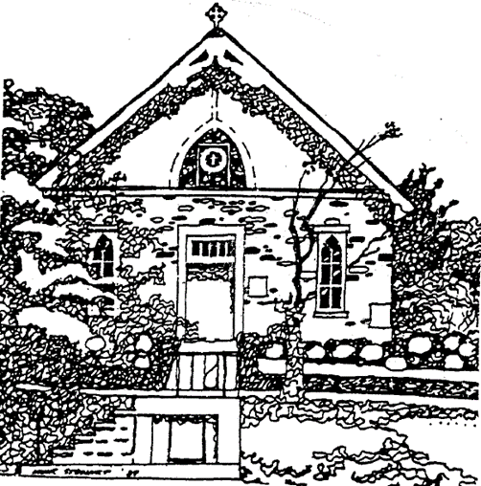

The Fourth Sunday after the Epiphany
Holy Eucharist – Rite II

January 29, 2023

Order of Worship

Prelude Ave Verum W. A. Mozart
Entrance Hymn Lord, make us servants Hymnal 593
Word of God BCP Page 355
Gloria in excelsis S-280
Collect of the Day Insert

The Liturgy of the Word

First Reading – Micah 6:1-8 Insert
Psalm 15 Insert
Second Reading – 1 Corinthians 1:18-31 Insert
Sequence Hymn Blest are the pure in heart Hymnal 656
Gospel – Matthew 5:1-12 Insert
Sermon Rev. Liston Garfield
Nicene Creed BCP Page 358
Prayers of the People, Form III BCP Page 387
Confession of Sin BCP Page 360
The Peace BCP Page 360
Announcements

The Holy Communion

Offertory Hymn O waly, waly R. J. Powell
Presentation Hymn Hymnal 11 (verse 4)
Eucharistic Prayer B BCP Page 367
Sanctus S-129
The Lord’s Prayer BCP Page 368
The Breaking of the Bread BCP Page 368
Fraction Anthem S-154
Communion Hymn Remember your servants Hymnal 560
Post Communion Prayer BCP Page 365
Recessional Hymn Christ is the world’s true Light Hymnal 542
Dismissal BCP Page 102
Postlude

Prayers of the People

Filip A., Carol A., Marie A., Petr A., Bob B., Sara B., Tim B.,
John C., Patrick C., David D., Barbara D., Francie G., Jitka H.,
Rosalie H., Fred H., Michael H., Judy J., Lois J., Thomas J.,
Jack K., Meredith K., Greg & Ilene L., Jan L., Jay L., Rob L.,
Mary Kay L., Tom L., Bill M., John M., Linda M., Robbie M.,
Nancy P., Jack & Renee R., Mike & Jacqueline R. ,Ron R., Ann R., Janeth & Fred S., Joanne & Bill S., Ken S., Judy W., Blanche W.,
Beth & Frank Y.

In Thanksgiving For: The Children of Emmanuel Church,
Emmanuel’s anonymous donors

For Those Who Have Died: Beth Y.

Announcements

Sunday school today following the service
Parish Annual meeting and Potluck following the service

February 2 Compline Service 6 pm
February 9 Compline Service 6 pm
February 12 Sunday School following the service

February 21 Shrove Tuesday Pancake Supper 5-7 pm

Emmanuel’s Service Schedule – Sunday – 10:00 am
February 5 Morning Prayer, Rite II
February 12 Holy Eucharist, Rite II – Rev. Liston Garfield
February 19 Morning Prayer, Rite II
February 26 Holy Eucharist, Rite I - Rev. Liston Garfield

The people of Emmanuel Church offer a warm welcome to our guests. Please take a moment to sign our guest book near the front door. All baptized Christians of every denomination are encouraged to receive Holy Eucharist. If you are unable to come to the altar rail, please let the usher know you would like to receive the consecrated bread and wine in your pew.

